**(SSE-21/12/256/2)- DESIGN AND ANALYSIS OF SURFACE CURRENT DISTRIBUTION AT 2.4 GHz and COMPARE WITH and WITHOUT SLOT**

**PICO:**

**Problem:** Current orientation is difficult

**Intervention:** slot creation method

**Comparison:** Current distribution of with and without slot

**Outcome:** Frequency vs Current distribution (with and without slot)

**INTRODUCTION:**

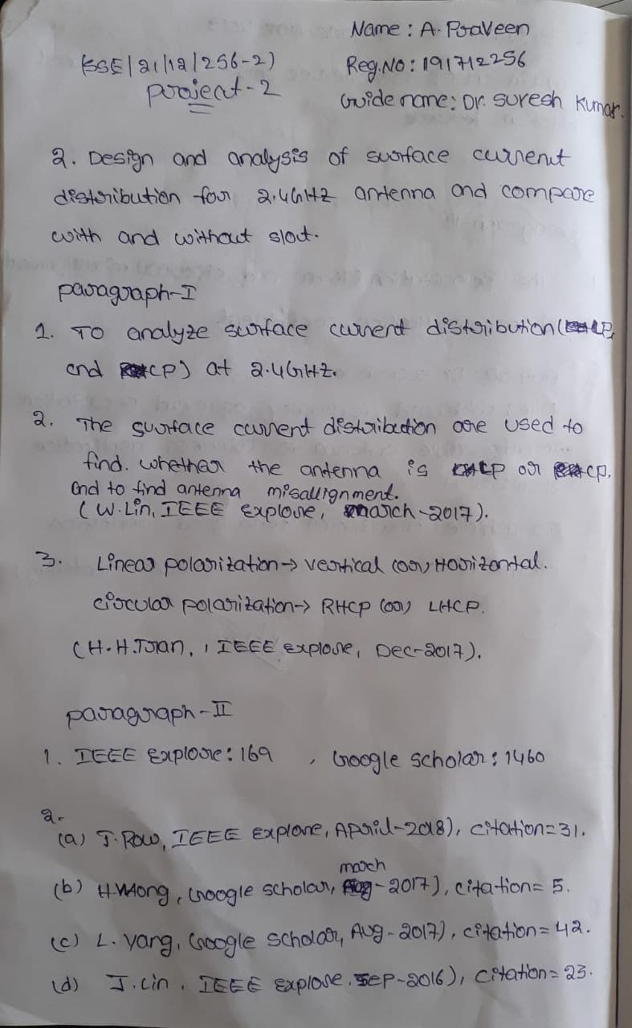



**MATERIALS AND METHODS**



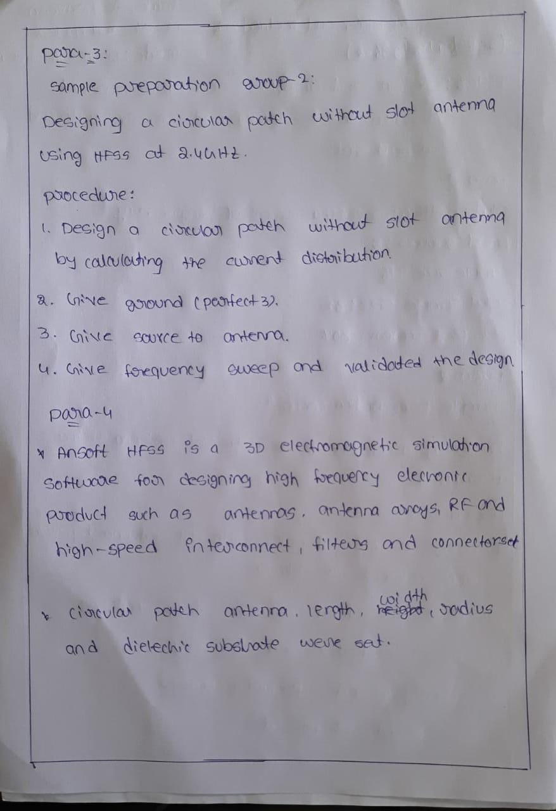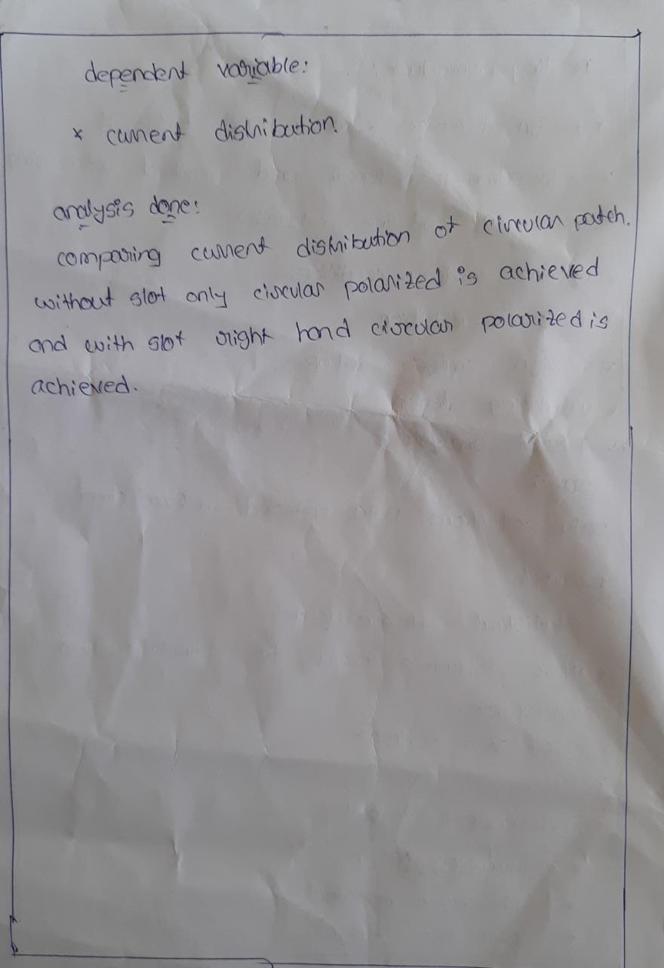

**DESIGN AND ANALYSIS OF SURFACE CURRENT DISTRIBUTION AT 2.4 GHz and COMPARE WITH and WITHOUT SLOT**

**DATA COLLECTION: WITH AND WITHOUT SLOT**

|  |  |  |  |  |  |  |
| --- | --- | --- | --- | --- | --- | --- |
| S.NO | GROUP1 | FREQUENCY | CURRENT DISTRIBUTION | GROUP2 | FREQUENCY | CURRENT DISTRIBUTION |
| 1 | 1 | 2.25 | -.1320 | 2 | 2.25 | -.2210 |
| 2 | 1 | 2.30 | -.1420 | 2 | 2.30 | -.3710 |
| 3 | 1 | 2.35 | -.4280 | 2 | 2.35 | -.7140 |
| 4 | 1 | 2.40 | -.1420 | 2 | 2.40 | -.5640 |
| 5 | 1 | 2.45 | -.8510 | 2 | 2.45 | -.4280 |
| 6 | 1 | 2.50 | -.5710 | 2 | 2.50 | -.7850 |
| 7 | 1 | 2.55 | -.2850 | 2 | 2.55 | -.1420 |
| 8 | 1 | 2.60 | -.2430 | 2 | 2.60 | -.5000 |
| 9 | 1 | 2.65 | -.7140 | 2 | 2.65 | -.8570 |
| 10 | 1 | 2.70 | -.4280 | 2 | 2.70 | -.2410 |
| 11 | 1 | 2.75 | -.1420 | 2 | 2.75 | -.5710 |
| 12 | 1 | 2.80 | -.8570 | 2 | 2.80 | -.2860 |
| 13 | 1 | 2.85 | -.5710 | 2 | 2.85 | -.2850 |
| 14 | 1 | 2.90 | -.2850 | 2 | 2.90 | -.6420 |
| 15 | 1 | 2.95 | -.4330 | 2 | 2.95 | -.1560 |
| 16 | 1 | 3.00 | -.3220 | 2 | 3.00 | -.3340 |

**Group Statistics:**

|  |  |  |  |  |  |
| --- | --- | --- | --- | --- | --- |
|  | group | N | Mean | Std. Deviation | Std. Error Mean |
| frequency | withslot | 16 | 2.6250 | .23805 | .05951 |
| withoutslot | 16 | 2.6250 | .23805 | .05951 |
| Current distribution | withslot | 16 | -.409125 | .2448607 | .0612152 |
| withoutslot | 16 | -.443562 | .2259251 | .0564813 |

|  |  |  |  |  |  |
| --- | --- | --- | --- | --- | --- |
| **Independent Samples Test** | | | | | |
|  | | Levene's Test for Equality of Variances | | t-test for Equality of Means | |
| F | Sig. | t | df |
|
| frequency | Equal variances assumed | .000 | 0.453 | .000 | 30 |
| Equal variances not assumed |  |  | .000 | 30.000 |
| Current distribution | Equal variances assumed | .022 | 0.434 | .413 | 30 |
| Equal variances not assumed |  |  | .413 | 29.808 |

Comparison of current distribution of with and without slot by varying the frequency ranging from 1GHz to 3GHz.there is statistically significant difference in current distribution of with and without slot. The current distribution of without slot is higher when compare to with slot.

**BAR CHART:**

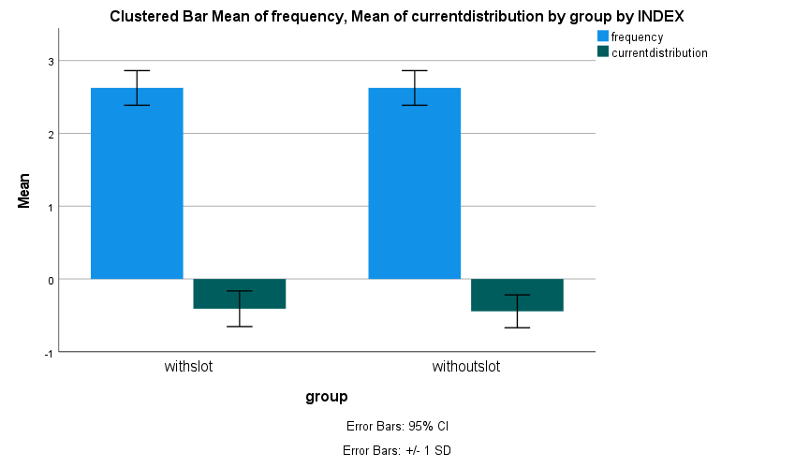

Fig. Bar chart comparing the mean current distribution of with and without slot by varying the frequency. There is no significance difference between the two groups p>0.05(Independent sample t test).

**RESULTS AND DISCUSSION:**

**WITHOUT SLOT CURRENT DISTRIBUTION:**

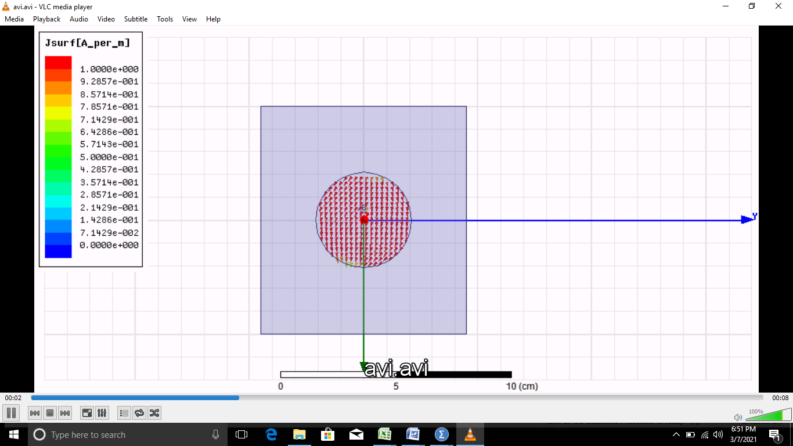

**Without slot only circular polarization(CP) is achieved in the current distribution.**

**WITH SLOT CURRENT DISTRIBUTION:**

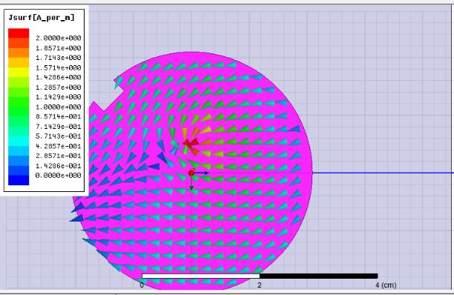

**With slot only right hand circular polarization(RHCP) is achieved in the current distribution.**

**DISCUSSION HINTS**



